|  |
| --- |
| **Name: MALAVIKA A**  **Roll No: 16**  **Batch: RMCA B**  **Date: 30-8-2022** |

**MOBILE APPLICATION DEVELEPOMENT LAB**

Android lab cycle:2

**Experiment No.:** 1

**Aim**

Design a Login Form with username and password using LinearLayout and toast valid credentials

**Procedure**

**activity_main.xml**

<?xml version="1.0" encoding="utf-8"?>

<LinearLayout xmlns:android="http://schemas.android.com/apk/res/android"

xmlns:tools="http://schemas.android.com/tools"

android:layout_width="match_parent"

android:layout_height="match_parent"

xmlns:card_view="http://schemas.android.com/apk/res-auto"

tools:context=".MainActivity"

android:gravity="center"

android:orientation="vertical"

>

<androidx.cardview.widget.CardView

android:layout_width="match_parent"

android:layout_height="wrap_content"

android:layout_margin="70dp"

android:background="#fff"

card_view:cardCornerRadius="10dp"

android:layout_gravity="center"

card_view:cardElevation="8dp">

<LinearLayout

android:layout_width="match_parent"

android:layout_height="wrap_content"

android:orientation="vertical"

android:layout_gravity="center"

android:padding="24dp">

<TextView

android:layout_width="match_parent"

android:layout_height="wrap_content"

android:layout_gravity="center_horizontal"

android:text="LOGIN"

android:textAlignment="center"

android:textSize="36sp" />

<TextView

android:layout_width="wrap_content"

android:layout_height="wrap_content"

android:hint="Username"

android:textSize="22sp" />

<EditText

android:id="@+id/activity_main_usernameEditText"

android:layout_width="match_parent"

android:layout_height="wrap_content"

android:inputType="text" />

<TextView

android:layout_width="wrap_content"

android:layout_height="wrap_content"

android:hint="Password"

android:textSize="22sp" />

<EditText

android:id="@+id/activity_main_passwordEditText"

android:layout_width="match_parent"

android:layout_height="wrap_content"

android:inputType="textPassword" />

<Button

android:id="@+id/activity_main_loginButton"

android:layout_width="match_parent"

android:layout_height="wrap_content"

android:text="Login"

android:textSize="22sp" />

</LinearLayout>

</androidx.cardview.widget.CardView>

</LinearLayout>

**Main_Activity.java**

package com.example.loginlab2;

import androidx.appcompat.app.AppCompatActivity;

import android.os.Bundle;

import android.view.View;

import android.widget.Button;

import android.widget.EditText;

import android.widget.Toast;

public class MainActivity extends AppCompatActivity {

private EditText usernameEditText;

private EditText passwordEditText;

private Button loginButton;

@Override

protected void onCreate(Bundle savedInstanceState) {

super.onCreate(savedInstanceState);

setContentView(R.layout.activity_main);

usernameEditText = findViewById(R.id.activity_main_usernameEditText);

passwordEditText = findViewById(R.id.activity_main_passwordEditText);

loginButton = findViewById(R.id.activity_main_loginButton);

loginButton.setOnClickListener(new View.OnClickListener() {

@Override

public void onClick(View v) {

if (usernameEditText.getText().length() > 0 && passwordEditText.getText().length() > 0) {

String toastMessage = "Username: " + usernameEditText.getText().toString() + ", Password: " + passwordEditText.getText().toString();

Toast.makeText(getApplicationContext(), toastMessage, Toast.LENGTH_SHORT).show();

} else {

String toastMessage = "Username or Password are not populated";

Toast.makeText(getApplicationContext(), toastMessage, Toast.LENGTH_SHORT).show();

}

}

});

}

}

OUTPUT

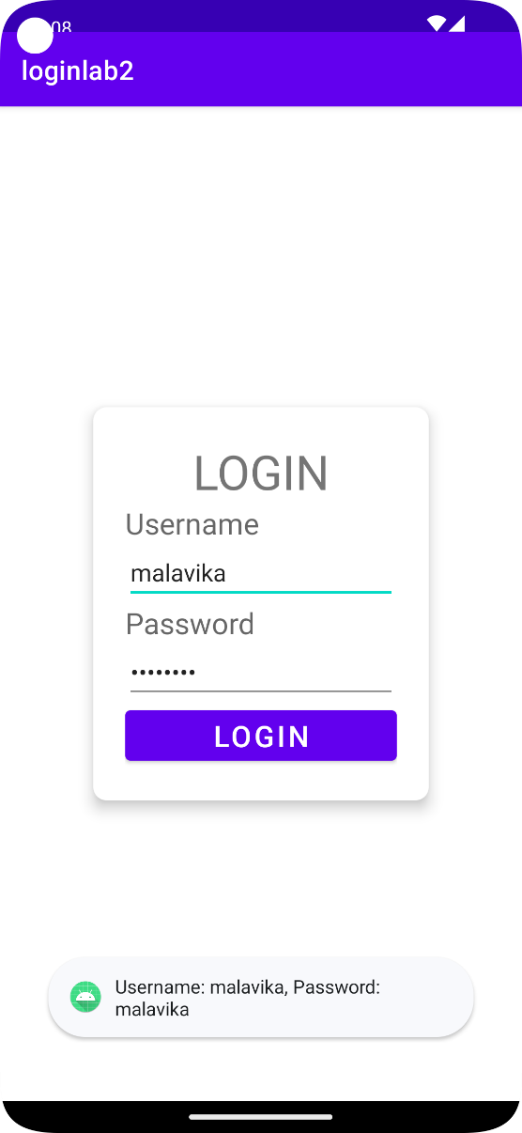

|  |
| --- |
| **Name: MALAVIKA A**  **Roll No: 16**  **Batch: RMCA B**  **Date: 30-8-2022** |

**MOBILE APPLICATION DEVELEPOMENT LAB**

Android lab cycle:2

**Experiment No.:** 2

**Aim**

Create an application to design a Visiting Card. The Visiting card should have a company logo at the top right corner. The company name should be displayed in Capital letters, aligned to the centre. Information like the name of the employee, job title, phone number, address, email, fax and the website address is to be displayed. Insert a horizontal line between the job title and the phone number.

**Procedure**

**activity_main.xml**

<?xml version="1.0" encoding="utf-8"?>

<androidx.constraintlayout.widget.ConstraintLayout xmlns:android="http://schemas.android.com/apk/res/android"

xmlns:app="http://schemas.android.com/apk/res-auto"

xmlns:tools="http://schemas.android.com/tools"

android:layout_width="match_parent"

android:layout_height="match_parent"

tools:context=".MainActivity">

<TextView

android:id="@+id/textView"

android:layout_width="258dp"

android:layout_height="305dp"

tools:layout_editor_absoluteX="76dp"

tools:layout_editor_absoluteY="213dp" />

<TextView

android:id="@+id/textView6"

android:layout_width="258dp"

android:layout_height="305dp"

tools:layout_editor_absoluteX="76dp"

tools:layout_editor_absoluteY="213dp" />

<TextView

android:id="@+id/textView7"

android:layout_width="258dp"

android:layout_height="305dp"

tools:layout_editor_absoluteX="76dp"

tools:layout_editor_absoluteY="213dp" />

<TextView

android:id="@+id/textView8"

android:layout_width="188dp"

android:layout_height="53dp"

android:gravity="center"

android:text="Revathy Ramankulangara Nagar-155 Kavanad P.O Kollam"

tools:layout_editor_absoluteX="111dp"

tools:layout_editor_absoluteY="409dp" />

<TextView

android:id="@+id/textView9"

android:layout_width="183dp"

android:layout_height="19dp"

android:gravity="center"

android:text="7560911972"

tools:layout_editor_absoluteX="111dp"

tools:layout_editor_absoluteY="378dp" />

<TextView

android:id="@+id/textView10"

android:layout_width="183dp"

android:layout_height="19dp"

android:gravity="center"

android:text="malavikagnimitra55@gmail.com"

tools:layout_editor_absoluteX="114dp"

tools:layout_editor_absoluteY="474dp" />

<TextView

android:id="@+id/textView5"

android:layout_width="183dp"

android:layout_height="19dp"

android:gravity="center"

android:text="Student"

tools:layout_editor_absoluteX="111dp"

tools:layout_editor_absoluteY="346dp" />

<TextView

android:id="@+id/textView3"

android:layout_width="260dp"

android:layout_height="43dp"

android:gravity="center"

android:text="MAG SYSTEMS"

android:textColor="#020101"

android:textSize="20sp"

android:textStyle="bold"

tools:layout_editor_absoluteX="57dp"

tools:layout_editor_absoluteY="250dp" />

<EditText

android:id="@+id/editTextTextPersonName"

android:layout_width="250dp"

android:layout_height="47dp"

android:ems="10"

android:inputType="textPersonName"

android:textSize="16sp"

tools:layout_editor_absoluteX="76dp"

tools:layout_editor_absoluteY="250dp" />

<ImageView

android:id="@+id/imageView"

android:layout_width="41dp"

android:layout_height="43dp"

tools:layout_editor_absoluteX="263dp"

tools:layout_editor_absoluteY="250dp"

tools:srcCompat="@tools:sample/backgrounds/scenic" />

<TextView

android:id="@+id/textView4"

android:layout_width="183dp"

android:layout_height="19dp"

android:text="Malavika A"

android:gravity="center"

tools:layout_editor_absoluteX="111dp"

tools:layout_editor_absoluteY="310dp" />

</androidx.constraintlayout.widget.ConstraintLayout>

**Main_Activity.java**

**OUTPUT**

|  |
| --- |
| **Name: MALAVIKA A**  **Roll No: 16**  **Batch: RMCA B**  **Date: 30-8-2022** |

**MOBILE APPLICATION DEVELEPOMENT LAB**

Android lab cycle:2

**Experiment No.:** 3

**Aim**

Develop an Android application using controls like Button, TextView, EditText for designing a calculator having basic functionality like Addition, Subtraction, Multiplication, and Division.

**Procedure**

**activity_main.xml**

**activity_main.xml**

<?xml version="1.0" encoding="utf-8"?>

<androidx.constraintlayout.widget.ConstraintLayout xmlns:android="http://schemas.android.com/apk/res/android"

xmlns:app="http://schemas.android.com/apk/res-auto"

xmlns:tools="http://schemas.android.com/tools"

android:layout_width="match_parent"

android:layout_height="match_parent"

android:backgroundTint="#B73A53"

tools:context=".MainActivity">

<Button

android:id="@+id/button18"

android:layout_width="56dp"

android:layout_height="47dp"

android:background="#FFEB3B"

android:text="1"

android:textAppearance="@style/TextAppearance.AppCompat.Small"

tools:layout_editor_absoluteX="47dp"

tools:layout_editor_absoluteY="361dp" />

<Button

android:id="@+id/button19"

android:layout_width="56dp"

android:layout_height="47dp"

android:background="#9C27B0"

android:text="9"

android:textAppearance="@style/TextAppearance.AppCompat.Small"

tools:layout_editor_absoluteX="242dp"

tools:layout_editor_absoluteY="509dp" />

<Button

android:id="@+id/button20"

android:layout_width="56dp"

android:layout_height="47dp"

android:background="#5A712E"

android:text="6"

android:textAppearance="@style/TextAppearance.AppCompat.Small"

tools:layout_editor_absoluteX="242dp"

tools:layout_editor_absoluteY="439dp" />

<Button

android:id="@+id/button21"

android:layout_width="56dp"

android:layout_height="47dp"

android:background="#FF9800"

android:text="3"

android:textAppearance="@style/TextAppearance.AppCompat.Small"

tools:layout_editor_absoluteX="242dp"

tools:layout_editor_absoluteY="361dp" />

<Button

android:id="@+id/button22"

android:layout_width="56dp"

android:layout_height="47dp"

android:background="#9C27B0"

android:text="8"

android:textAppearance="@style/TextAppearance.AppCompat.Small"

tools:layout_editor_absoluteX="148dp"

tools:layout_editor_absoluteY="509dp" />

<Button

android:id="@+id/button23"

android:layout_width="56dp"

android:layout_height="47dp"

android:background="#FFC107"

android:text="2"

android:textAppearance="@style/TextAppearance.AppCompat.Small"

tools:layout_editor_absoluteX="148dp"

tools:layout_editor_absoluteY="361dp" />

<Button

android:id="@+id/button15"

android:layout_width="56dp"

android:layout_height="47dp"

android:background="#00BCD4"

android:text="AC"

android:textAppearance="@style/TextAppearance.AppCompat.Small"

tools:layout_editor_absoluteX="329dp"

tools:layout_editor_absoluteY="657dp" />

<Button

android:id="@+id/button16"

android:layout_width="56dp"

android:layout_height="47dp"

android:background="#CDDC39"

android:text="5"

android:textAppearance="@style/TextAppearance.AppCompat.Small"

tools:layout_editor_absoluteX="148dp"

tools:layout_editor_absoluteY="439dp" />

<Button

android:id="@+id/button17"

android:layout_width="56dp"

android:layout_height="47dp"

android:background="#CDDC39"

android:text="7"

android:textAppearance="@style/TextAppearance.AppCompat.Small"

tools:layout_editor_absoluteX="47dp"

tools:layout_editor_absoluteY="509dp" />

<Button

android:id="@+id/button13"

android:layout_width="56dp"

android:layout_height="47dp"

android:background="#FFEB3B"

android:text="4"

android:textAppearance="@style/TextAppearance.AppCompat.Small"

tools:layout_editor_absoluteX="47dp"

tools:layout_editor_absoluteY="439dp" />

<Button

android:id="@+id/button14"

android:layout_width="56dp"

android:layout_height="47dp"

android:background="#9C27B0"

android:text="C"

android:textAppearance="@style/TextAppearance.AppCompat.Small"

tools:layout_editor_absoluteX="242dp"

tools:layout_editor_absoluteY="590dp" />

<Button

android:id="@+id/button12"

android:layout_width="56dp"

android:layout_height="47dp"

android:background="#F44336"

android:text="0"

android:textAppearance="@style/TextAppearance.AppCompat.Small"

tools:layout_editor_absoluteX="47dp"

tools:layout_editor_absoluteY="585dp" />

<Button

android:id="@+id/button10"

android:layout_width="53dp"

android:layout_height="40dp"

android:background="#FF9800"

android:text="+"

tools:layout_editor_absoluteX="329dp"

tools:layout_editor_absoluteY="509dp" />

<Button

android:id="@+id/button11"

android:layout_width="53dp"

android:layout_height="42dp"

android:background="#03A9F4"

android:text="/"

tools:layout_editor_absoluteX="329dp"

tools:layout_editor_absoluteY="590dp" />

<Button

android:id="@+id/button9"

android:layout_width="51dp"

android:layout_height="43dp"

android:background="#2196F3"

android:text="*"

tools:layout_editor_absoluteX="329dp"

tools:layout_editor_absoluteY="361dp" />

<Button

android:id="@+id/button8"

android:layout_width="50dp"

android:layout_height="45dp"

android:background="#FFC107"

android:text="-"

tools:layout_editor_absoluteX="329dp"

tools:layout_editor_absoluteY="439dp" />

<Button

android:id="@+id/button"

android:layout_width="54dp"

android:layout_height="48dp"

android:background="#E91E63"

android:text="="

tools:layout_editor_absoluteX="150dp"

tools:layout_editor_absoluteY="585dp" />

<TextView

android:id="@+id/textView"

android:layout_width="395dp"

android:layout_height="256dp"

android:layout_marginTop="84dp"

app:layout_constraintTop_toTopOf="parent"

tools:layout_editor_absoluteX="8dp" />

<TextView

android:id="@+id/textView2"

android:layout_width="412dp"

android:layout_height="88dp"

android:background="#673AB7"

android:gravity="center"

android:text="CALCULATOR"

android:textSize="34sp"

tools:layout_editor_absoluteX="2dp"

tools:layout_editor_absoluteY="-2dp" />

</androidx.constraintlayout.widget.ConstraintLayout>

OUTPUT

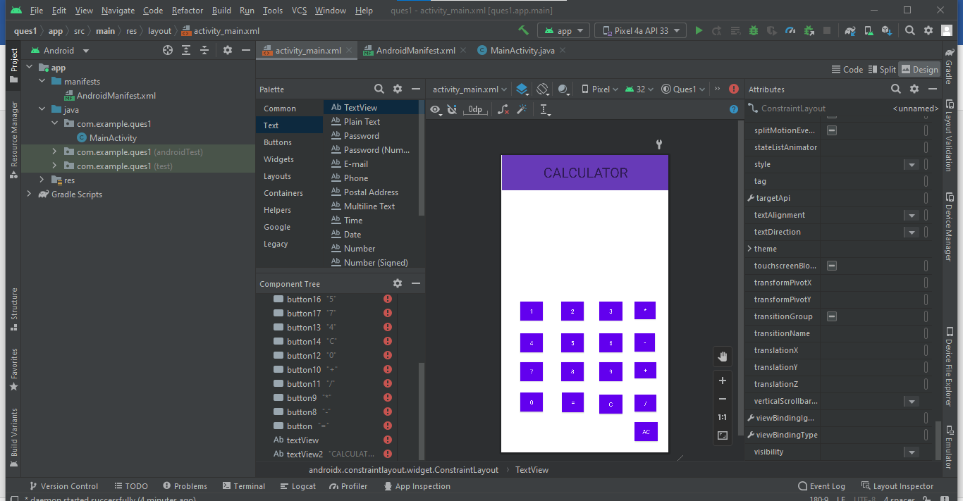

|  |
| --- |
| **Name: MALAVIKA A**  **Roll No: 16**  **Batch: RMCA B**  **Date: 20-09-2022** |

**MOBILE APPLICATION DEVELEPOMENT LAB**

Android lab cycle:2

**Experiment No.:** 2

**Aim**

Create a facebook page using relative layouts. Implement validations on UI controls.

**Procedure**

**activity_main.xml**

<?xml version="1.0" encoding="utf-8"?>

<RelativeLayout xmlns:android="http://schemas.android.com/apk/res/android"

xmlns:app="http://schemas.android.com/apk/res-auto"

xmlns:tools="http://schemas.android.com/tools"

android:id="@+id/activity_main"

android:layout_width="match_parent"

android:layout_height="match_parent"

android:background="#5F73F1">

<EditText

android:id="@+id/text1"

android:layout_width="match_parent"

android:layout_height="wrap_content"

android:layout_alignParentTop="true"

android:layout_marginLeft="18dp"

android:layout_marginTop="245dp"

android:layout_marginRight="18dp"

android:background="#fff"

android:hint="Username"

android:padding="8dp" />

<EditText

android:id="@+id/text2"

android:layout_width="match_parent"

android:layout_height="wrap_content"

android:layout_below="@+id/text1"

android:layout_marginLeft="18dp"

android:layout_marginTop="30dp"

android:layout_marginRight="18dp"

android:background="#fff"

android:hint="Password"

android:padding="8dp" />

<Button

android:id="@+id/b1"

android:layout_width="match_parent"

android:layout_height="wrap_content"

android:layout_below="@+id/text2"

android:layout_alignStart="@+id/text2"

android:layout_alignEnd="@+id/text2"

android:layout_marginStart="3dp"

android:layout_marginTop="25dp"

android:layout_marginEnd="-1dp"

android:text="Login"

android:textColor="#00CC99" />

<TextView

android:id="@+id/text3"

android:layout_width="wrap_content"

android:layout_height="wrap_content"

android:layout_below="@+id/b1"

android:layout_alignParentEnd="true"

android:layout_alignParentRight="true"

android:layout_marginTop="79dp"

android:layout_marginEnd="112dp"

android:layout_marginRight="112dp"

android:text="Not a member?Sign up now"

android:textColor="#fff" />

<TextView

android:id="@+id/textView4"

android:layout_width="359dp"

android:layout_height="171dp"

android:fontFamily="sans-serif"

android:gravity="center"

android:text="facebook"

android:textSize="48sp" />

</RelativeLayout>

**Main_Activity.java**

package com.example.fb;

import androidx.appcompat.app.AppCompatActivity;

import android.os.Bundle;

import android.view.View;

import android.widget.Button;

import android.widget.EditText;

import android.widget.Toast;

public class MainActivity extends AppCompatActivity {

private EditText usernameEditText;

private EditText passwordEditText;

private Button loginButton;

@Override

protected void onCreate(Bundle savedInstanceState) {

super.onCreate(savedInstanceState);

setContentView(R.layout.activity_main);

usernameEditText = findViewById(R.id.text1);

passwordEditText = findViewById(R.id.text2);

loginButton = findViewById(R.id.b1);

loginButton.setOnClickListener(new View.OnClickListener() {

@Override

public void onClick(View v) {

if (usernameEditText.getText().length() > 0 &&

passwordEditText.getText().length() > 0) {

String toastMessage = "Username: " +

usernameEditText.getText().toString() + ", Password: " +

passwordEditText.getText().toString();

Toast.makeText(getApplicationContext(), toastMessage,

Toast.LENGTH_SHORT).show();

} else {

String toastMessage = "Username or Password are not populated";

Toast.makeText(getApplicationContext(), toastMessage,

Toast.LENGTH_SHORT).show();

}

}

});

}

}

**OUTPUT**

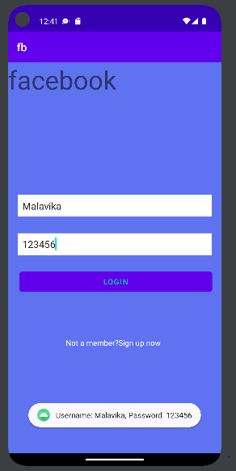

|  |
| --- |
| **Name: MALAVIKA A**  **Roll No: 16**  **Batch: RMCA B**  **Date: 20-09-2022** |

**MOBILE APPLICATION DEVELEPOMENT LAB**

Android lab cycle:2

**Experiment No.:** 2

**Aim**

Design a simple calculator using grid layout and cascaded linear layout.

**Procedure**

**activity_main.xml**

**Main_Activity.java**

**OUTPUT**